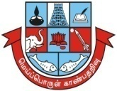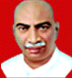**Madurai Kamaraj University**

(*University with Potential for Excellence)*

***(Re-accredited by NAAC with “ A++’’ in the 4th Cycle)***

**WOMEN’S STUDIES CENTRE**

***In collaboration with***



**Nagarathinam Angalammal Arts & Science College, Madurai-22**

(Affiliated to Madurai Kamaraj University)

&

**Youth Red Cross, Madurai**

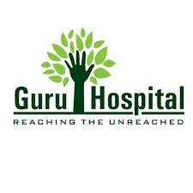

**&**

**GURU HOSPITAL, Madurai**

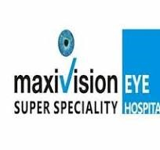

**&**

**Maxi Vision Eye Super Specialty Hospital**

**Madurai**

**Organize**

**FREE MEDICAL & EYE CHECK UP**

**Date:** 29.01.24 **Time:** 10. 00 a.m-1.00 p.m.

**Venue:** Auditorium, NAAS College **No. of Participants :** 650

The Women’s Studies Centre of Madurai Kamaraj University organized a Free Medical and Eye check-up in collaboration with Nagarathinam Angalammal Arts &Science College, Youth Red Cross, Guru Hospital, and Max Vision Eye Super Specialty Hospital at Nagarathinam Angalammal Arts and Science College Auditorium on 29th January 2024.

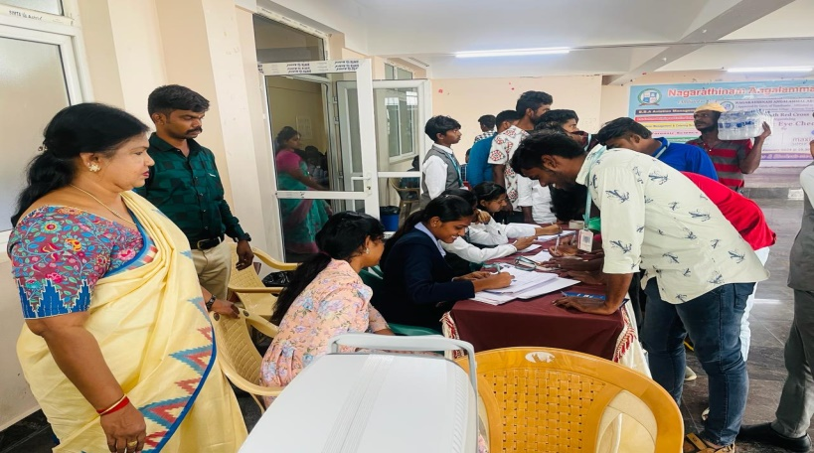

The program mainly covered college students and people living near the college. The program specifically aimed to give quick access to the health care needs of the people. It is a valuable tool in addressing health inequalities, creating awareness of maintaining good health and suggesting proper treatment for people. The health camp with the doctors and nurses from Guru Hospital and Max Vision Eye Super Specialty Hospital gave treatments for participants in general medicine, eye check-ups, Echo and ECG for the heart, and tests for cancer like Mammograms and pap smears. The health camp began sharply at 10.00 a.m. Participants were asked to register their details at the registration desk. The participants age, gender, and what kind of health check they would like to take were entered in the registration desk. An individual card for all the participants was maintained and they were asked to check their Blood Pressure, weight, and sugar test (was taken based on the preference of the participants). Patients who were already diagnosed with blood sugar came without eating and took the blood test for sugar.

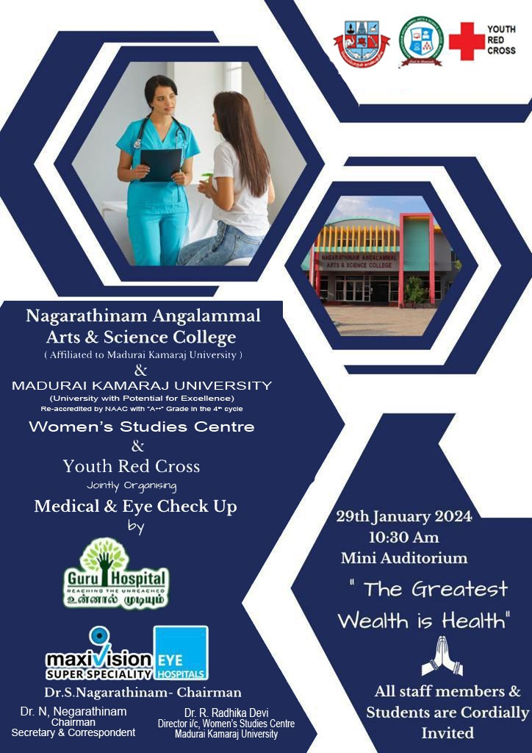

After this doctors from Guru Hospital and Max Vision Eye Super Specialty Hospital talked to the participants saying that everyone should go for health check-ups and especially people above the age of 35 should have compulsory tests for cholesterol, Blood Pressure, and sugar, changes in the levels of Blood Pressure, cholesterol, and sugar are the root cause of serious health problems. Many people both educated and uneducated imagine their health is good and ignore mild symptoms like giddiness, sleeplessness, shoulder pain, etc.

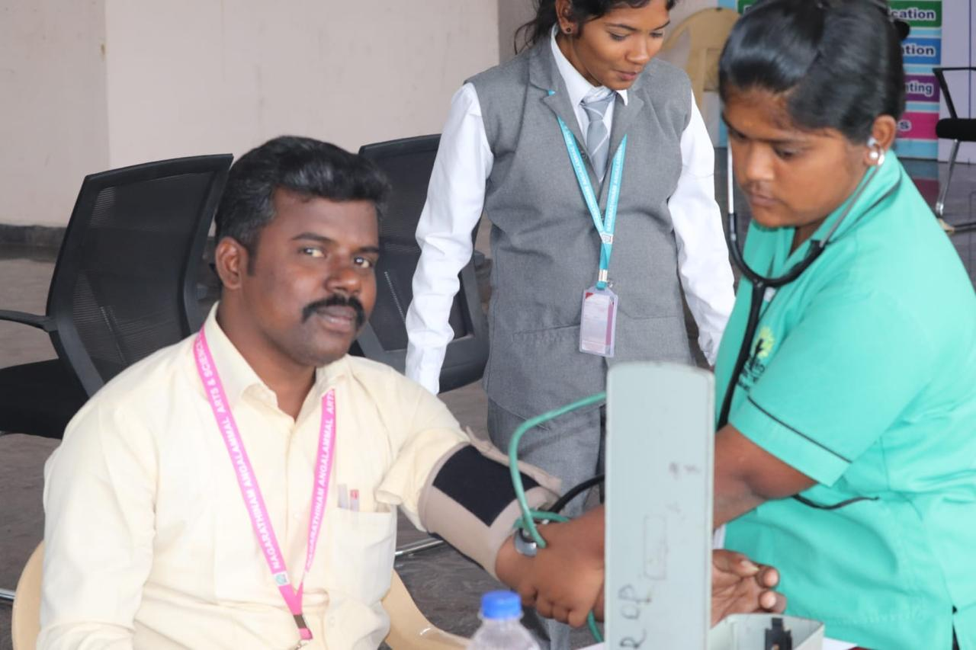

They are hesitating to go for health check-ups. Corona has taught us how vulnerable a disease can be and how easily it can take our lives. Especially women are completely ignoring their health fully involved in taking care of the family members and other domestic chores. When any health issue diagnosed in the beginning can be treated and cured easily. People are not aware that one disease or health problem will lead to other diseases or make our internal organs weak. We can see our external organs and if we have wounds are something else we can immediately treat the wound. But what happens to the internal organs how does it work we cannot see them directly and cannot treat them immediately like the external organs. If a health problem is left uncared it will be difficult and bigger health complications will lead to prolonged treatments. As you know these prolonged treatments would cost high it is difficult also to pay the medical bills. So prevention is better than cure. After this, the participants were sent for respective health check-ups. The participants for eye check-ups were given eye drops and were told to close their eyes for five minutes. After this, an ophthalmoscope enables a doctor to examine the inside of a person's eye.

The instrument has an angled mirror, various lenses, and a light source. The eye health checks will normally start with a slit lamp, which is a microscope that directs a beam of light into the eye to get a full picture of the sclera, cornea, lens, retina, and optic nerve. If there are changes in the ranges of our vision tests for glaucoma,  or [optic nerve damage](https://www.mayoclinic.org/diseases-conditions/optic-neuritis/symptoms-causes/syc-20354953) are done and medicines are prescribed for the participants. The doctor recommended the patients that eye is an important organ in our body only through eye we can see thing so once you are diagnoised with eye problem you should follow the instructions properly. The doctors prescribed eye drops, some patients were suggested for cataract operation and eye exercises for the eye problem to be 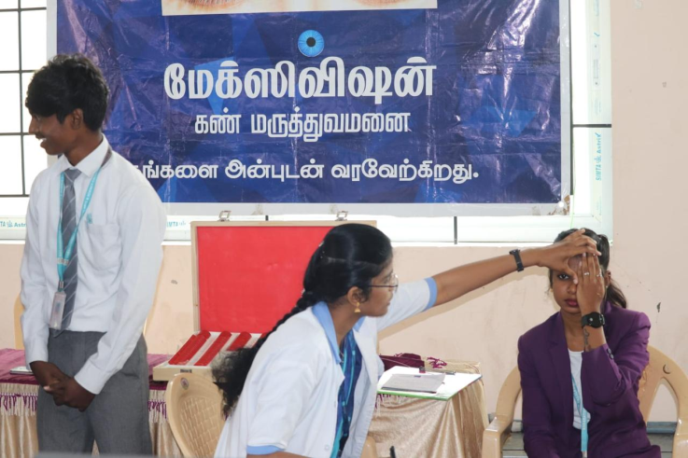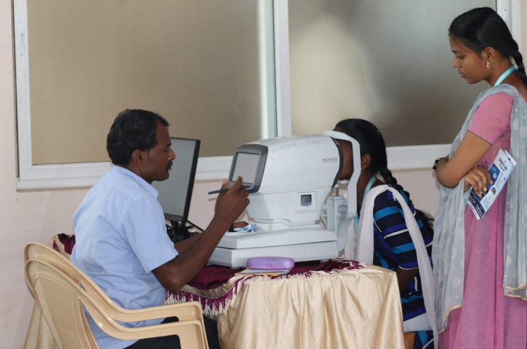cured.

Next, the patient for taking Echo and ECG test for made to assemble in a separate room. The health camp was arranged in such a way separate rooms were allotted for testing each health issue. Although ECG vs echocardiogram monitors the heart, they are specific tests. Using electrodes, an ECG detects abnormalities in the electrical impulses of the heart, whereas an echo cardiogram uses ultrasound to check for anomalies in the heart's structure.  Electrodes are connected to an ECG machine by lead wires. The electrical activity of the heart is then measured, interpreted, and printed out. No electricity is sent into the body. Natural electrical impulses coordinate contractions of the different parts of the heart to keep blood flowing the way it should. For Echo Test lubricating gel will be applied to the patient’s chest or directly to the ultrasound probe. You'll be asked to lie on your left side and the probe will be moved across your chest. The probe is attached by a cable to a nearby machine that will display and record the images of the heart. Based on the results of these tests the doctors suggested the medicines.

The doctors also commented that increase in cholesterol levels is the main reason for heart problems. The doctor after the Echo and ECG test advised the patients to make life style modification like walking regularly, intake of low carb diets, they suggested mainly to finish their dinner before 7.30 p.m. The doctors strongly advised that patients should not sleep immediately after taking their dinner. We should sleep only two hours after taking dinner. Patients should avoid oily foods and take foods that can be easily digested.

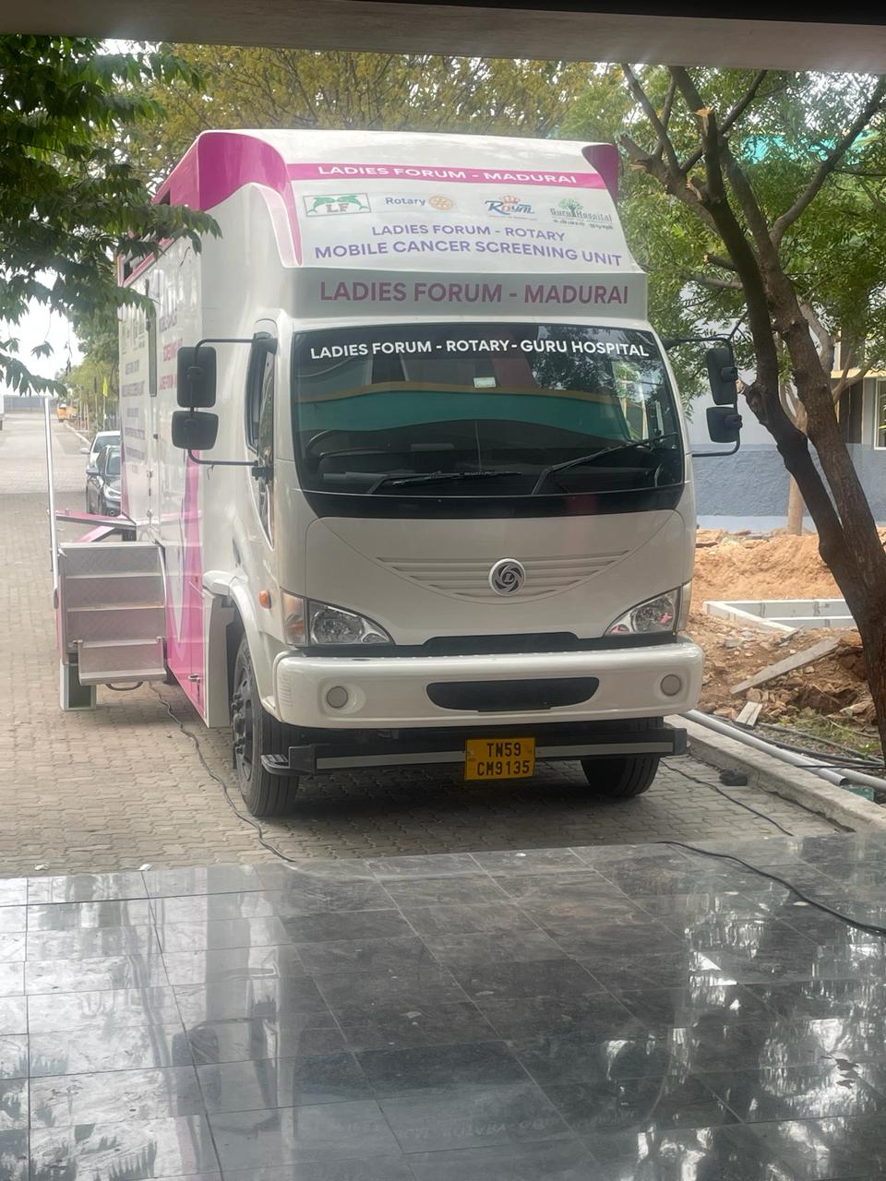

The next test is a pap smear and mammogram, a test for detecting cancer was taken as per the preference of the participants. A Pap smear, also called a Pap test, is a procedure to test for cervical cancer in women. It takes five minutes to do the test but it takes a long time for the preparation of the test. A Pap smear involves collecting cells from your cervix — the lower, narrow end of the uterus that's at the top of your vagina. Detecting cervical cancer early with a Pap smear gives you a greater chance at a cure. A Pap smear can also detect changes in your cervical cells that suggest cancer which may develop in the future. Detecting these abnormal cells early with a Pap smear is the first step in halting the possible development of cervical cancer. A mammogram is an X-ray picture of the breast. Doctors use a mammogram to look for early signs of breast cancer. Regular mammograms can find breast cancer early, sometimes up to three years before it can be felt. The patients are made to stand in front of a special X-ray machine. A technologist will place your breast on a plastic plate. Another plate will firmly press your breast from above. The plates will flatten the breast, holding it still while the X-ray is being taken. You will feel some pressure. The steps are repeated to make a side view of the breast. Some patients felt the pain while taking the mammogram test.At the end of each test the patients were made to take rest for five to ten minutes so that they would feel normal while taking another test.

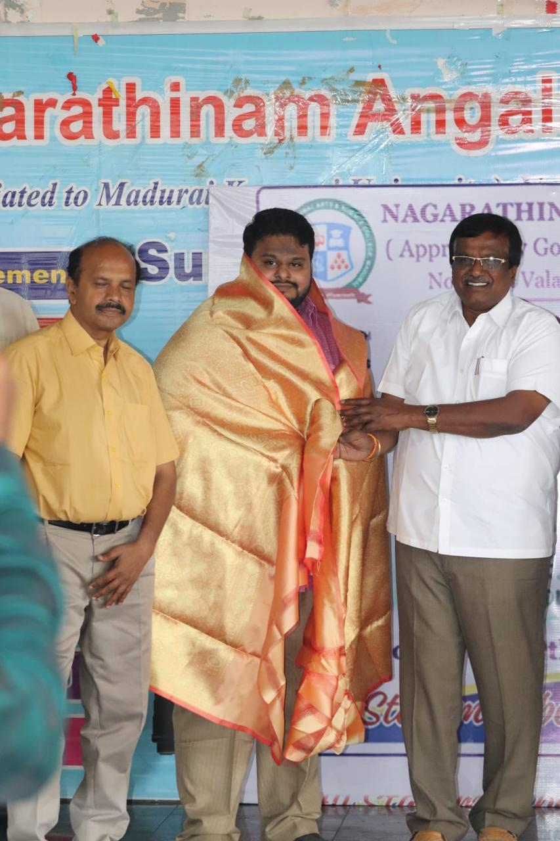 The health camp came to an end with a feedback session about the health camp. The patients shared that the health camp was useful for them. Many patients were not aware about their health problems only after taking tests from the health camp they come to know about their health problems. The Doctors were caring towards them, listened to their health problems patiently and suggested tests that were apt for them. They told it was a good opportunity to check their health.

**SPECIAL LECTURE**

**on**

**TIPS ON HEALTHY LIVING**

**Date: 07.03.2024 Time:11.00 a.m. : 2.00.p.m**

**Venue: Nagarathinam Angalammal Arts and No. of. Beneficiaries: 472**

**Science College**

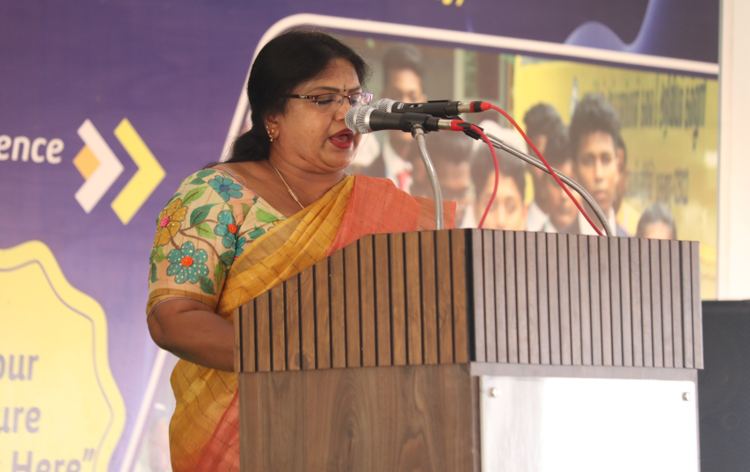The Women’s Studies Centre of Madurai Kamaraj University in collaboration with Naagarathinam Angalammal Arts and Science College, Women Empowerment cell organized a special lecture on “Tips on healthy living” on 07th March 2024 at NAAS College. The program was organized in commemoration of Women’s Day. The Program began with the welcome address by Dr.R.Radhika Devi, Director i/c, Women’s Studies Centre, Madurai Kamaraj University, Madurai. She in her welcome speech said that feeling good about yourself and taking care of your health are important for your self-esteem and self-image. Maintaining a healthy lifestyle by doing what is right for your body helps you to do whatever you want. But imagine yourself when you are sick you should be dependent on someone even for your basic needs. Because of unhealthy conditions, you may be restricted to one particular place. Choosing to live healthily is one of the best decisions. because not only does it help to decrease the number of health risks an individual may face in the future, but it also helps to increase one’s lifespan. It will help to increase your brain health and memory, as well as make you feel more energized throughout the day. You may be a rich person, having all the facilities, and you be the best in your profession but out of all this your good health is the top most wealth you have with which you can achieve things. She concluded her speech by requesting the participants to make use of the special lecture for their better living.

After the welcome address the special address was given by Ms.V.Suguna, Head, Department of Diabetics, Apollo Speciality Hospital, Madurai. She began her Special address by saying that ours is the generation of the computer, mobile, burgers, pizzas, and late-night parties, everything that is unhealthy. Everyone is caught up between professional commitments and personal issues and what they are losing amidst all this chaos is their health. People these days have become so involved in their daily grinds that they have forgotten what it is to live a wholesome and healthy life. Our elders often stress the need to have a nutritious diet, sleep and wake up on time each day, and go to nearby places on foot rather than using vehicles each time. However, most of us ignore their advice and continue with our unhealthy way of living. What they suggest is right. It is important to follow a healthy lifestyle. The need to switch to healthy habits is being stressed everywhere these days. Here is why it is important to follow a **healthy lifestyle:**

* It makes you more organized and increases productivity.
* Makes you physically fit and keeps several health issues at bay.
* It is a great way to live stress-free.
* Renders a positive outlook.
* It brings us closer to our family and loved ones.

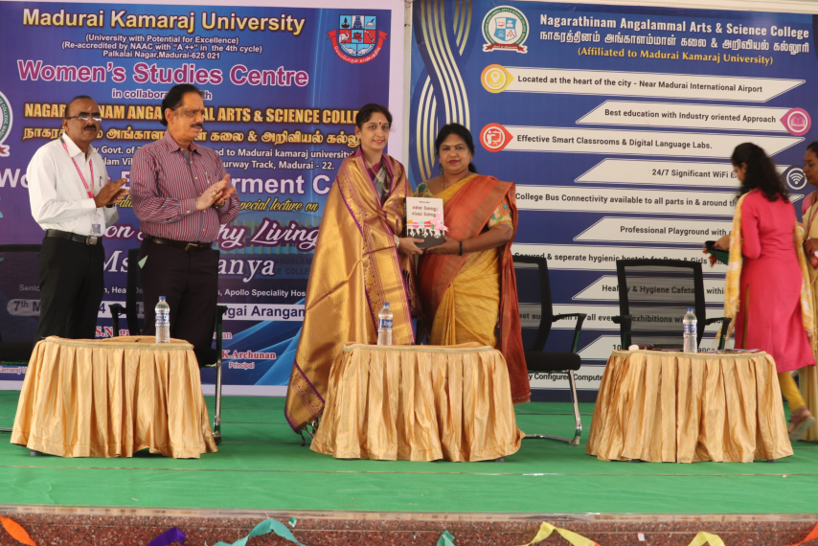

The resource person continued her speech by saying that, it is said that it is easy to learn and maintain bad habits but it is very difficult to switch them back. The issue of a healthy lifestyle is very serious but people take it very lightly. Often, it is seen that people take steps to improve their lifestyle but due to a lack of determination they quit the midway. Moreover, for a healthy lifestyle, it is important that you take small and one step at a time. Also, do not go overboard with it. Besides, this healthy lifestyle will help you in life in a lot of ways.  The main thing in a healthy lifestyle is healthy eating. It includes taking food that contains all the essential minerals and vitamins required by the body. Also, eat food that helps to function our organs properly for foods like millet, ragi, etc. We as Indians are famous for small grains like this and each small grain has its properties to maintain our body healthily. Healthy eating has both long-term as well as short-term benefits. While, short-term effects of **healthy eating** are – a raised nutrition level, a healthy digestive system, and raised immunity along with other advantages. Apart from having short-term advantages, healthy eating also has many long-term benefits. It prevents the occurrence of many lifestyle-related diseases like diabetes, high blood pressure, obesity, back pain spondylitis, etc.

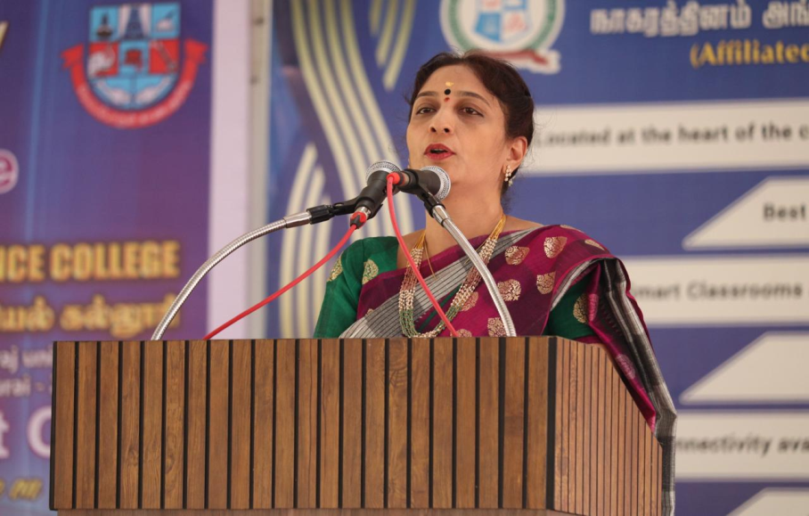

It also prevents us from other serious ailments like cancer, heart disease osteoporosis, etc. Those were the physical benefits of adapting to a healthy eating lifestyle, but there are also psychological benefits of it. A healthy eating will give you a healthy body and hence a healthy mind. With no diseases a fit body and a boosted immune system, you will be a happy person with ample energy and time for your career and growth. You will be as happy as ever and socialize more, admiring others as they admire you. Moreover, a healthy person inspires others to follow the path, ultimately leading to a healthy society. In addition, wake up early in the morning because first of all, it’s a healthy habit. Waking up early means you can get ready for your work early, and spend some quality time with your family. It is compulsory like how we eat three times a day we should also do our exercises regularly. The resource person continued her speech by saying that the benefits of doing exercise include stimulated health, improved immune system, increased organ efficiency, and improved brain health. Besides, this decide the time for your sleep and sleep early because it de-stresses the body. Doing exercise regularly makes your body more active and it also releases unexpressed stress from the muscles. Indulging in unhealthy habits such as smoking, drinking, having junk food, and spending too much time on screen can lead to various serious illnesses and should thus is avoided. While most of us are aware of the unhealthy habits we indulge in and many even try to quit the same, we often fall short. You cannot just wake up one day and decide to quit your unhealthy habits and voila you are done with it. No, it requires a lot of effort to quit such habits especially if you have been following them for a long period. Here are a few things that should help: the first thing you should do is to write down the cons of the bad habits you have been indulging in and the positive affects you can bring about in your life if you quit the same. Stick it at a place where you can read it often enough. This should work as an inspiration. There may be several things that might act as triggers. Avoid indoor activities for instance, if you have the habit of having chips and cookies when you are watching TV then cut out on the time you watch TV and you may follow something that interests you during your free time. It can be anything from playing with your dog to dancing to sketching. She concluded her speech by saying that it is in your hands to maintain your health. After the speech by the resource person the students exhibited their talents through their performance on speech, fashion show and group dance. Prizes were distributed t the students who have performed best. After the prize distribution the program came to an end with vote of thanks by Ms.R.Aruna, chairperson, Women Empowerment Cell, Naagarathinam Angalammal Arts and Science College, Madurai.

